NAME : Shri Harshini Devi . A
REG.NO : 192524104
COURSE CODE : DSA0602
COURSE NAME : Data handling and Visualization

Class Activity: 10.07.2026

Scenario 1: Student Academic Performance Dashboard
CODE:
# Student Academic Performance Dashboard

# Create dataset
student <- data.frame(
StudentID = c(101,102,103,104,105,106,107,108),
Attendance = c(92,85,78,95,88,81,90,76),
Marks = c(88,75,68,94,82,70,90,65),
Department = c("CSE","AI","IT","ECE","CSE","AI","IT","ECE")
)

# Load ggplot2 package
library(ggplot2)

# Scatter Plot
ggplot(student, aes(x = Attendance, y = Marks, color = Department)) +
geom_point(size = 3) +
labs(
title = "Student Academic Performance Dashboard",
x = "Attendance (%)",
y = "Internal Marks",
color = "Department"
) +
theme_minimal()

OUTPUT:

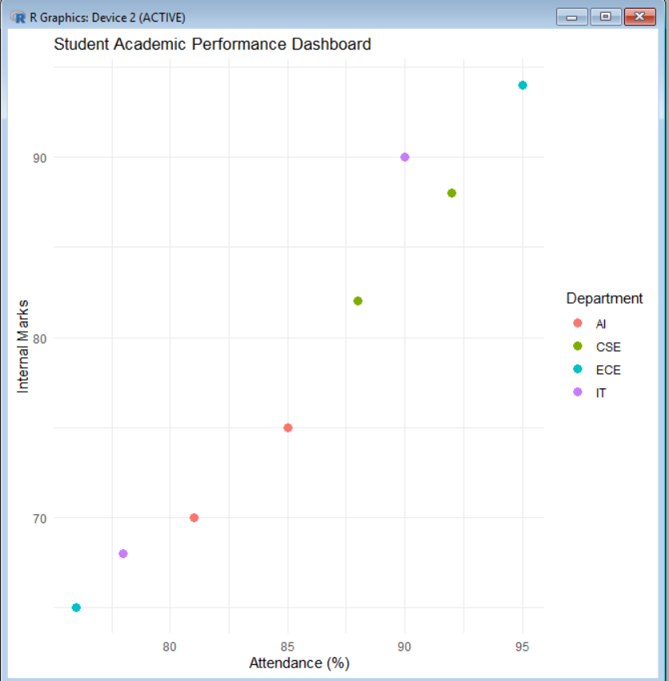

Scenario 2: Electric Vehicle Market Analysis

CODE:
# Load ggplot2 package
library(ggplot2)

# Create dataset
ev <- data.frame(
VehicleModel = c("Model A","Model B","Model C","Model D","Model E"),
BatteryCapacity = c(40, 50, 60, 75, 90),
Price = c(12, 16, 20, 28, 35), # Price in Lakhs
DrivingRange = c(250, 320, 400, 480, 550), # Range in km
Manufacturer = c("Tata", "MG", "Mahindra", "Hyundai", "BYD")
)

# Bubble Chart
ggplot(ev, aes(x = BatteryCapacity,
y = Price,
size = DrivingRange,
color = Manufacturer)) +
geom_point(alpha = 0.8) +
labs(
title = "Electric Vehicle Market Analysis",
x = "Battery Capacity (kWh)",
y = "Price (Lakhs)",
size = "Driving Range (km)",
color = "Manufacturer"
) +
theme_minimal()

OUTPUT:
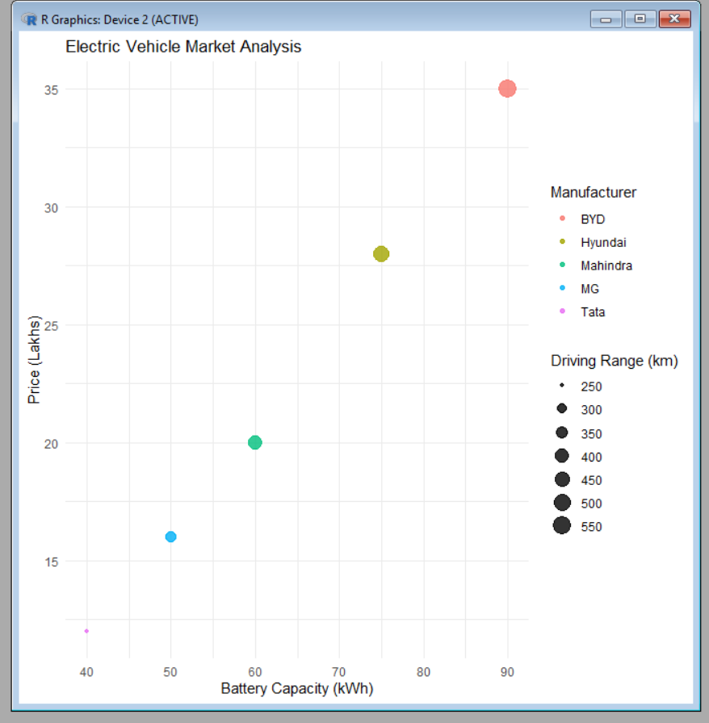

Scenario 3: Hospital Patient Admission Analysis

CODE:

# Load ggplot2 package
library(ggplot2)

# Create dataset
hospital <- data.frame(
Department = c("Cardiology", "Neurology", "Orthopedics", "Pediatrics", "General"),
Patients = c(120, 95, 80, 140, 160),
TreatmentCost = c(50000, 65000, 40000, 30000, 25000)
)

# Bar Chart
ggplot(hospital, aes(x = Department, y = Patients, fill = Department)) +
geom_bar(stat = "identity") +
geom_text(aes(label = TreatmentCost), vjust = -0.5, size = 4) +
labs(
title = "Hospital Patient Admission Analysis",
x = "Department",
y = "Number of Patients",
fill = "Department"
) +
theme_minimal()

OUTPUT:

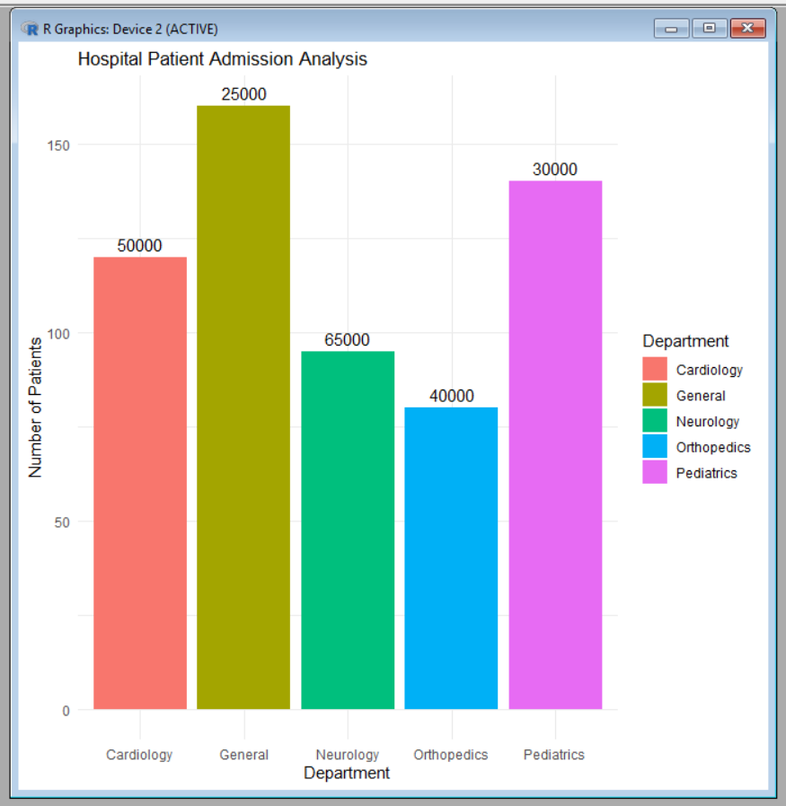
Scenario 4: Weather Monitoring System

CODE:
# Load ggplot2 package
library(ggplot2)

# Create dataset
weather <- data.frame(
Date = rep(1:5, 3),
Temperature = c(30, 31, 32, 33, 34,
28, 29, 30, 31, 32,
26, 27, 28, 29, 30),
City = rep(c("Chennai", "Bengaluru", "Delhi"), each = 5)
)

# Line Chart
ggplot(weather,
aes(x = Date,
y = Temperature,
color = City,
linetype = City,
group = City)) +
geom_line(size = 1) +
labs(
title = "Weather Monitoring System",
x = "Date",
y = "Temperature (°C)",
color = "City",
linetype = "City"
) +
theme_minimal()

OUTPUT:
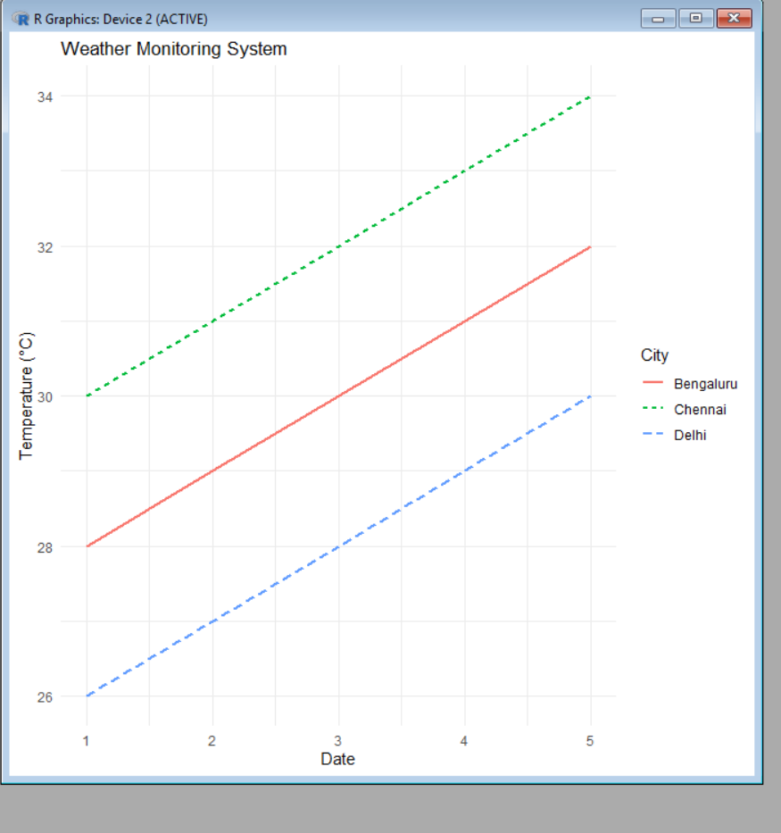

Scenario 5 : Supermarket Sales Analysis
CODE:
# Load ggplot2 package
library(ggplot2)

# Create dataset
sales <- data.frame(
Month = c("Jan","Jan","Jan","Jan","Feb","Feb","Feb","Feb"),
ProductCategory = c("Groceries","Groceries","Beverages","Beverages",
"Groceries","Groceries","Beverages","Beverages"),
SalesAmount = c(50000,45000,30000,35000,55000,48000,32000,38000),
Branch = c("Branch A","Branch B","Branch A","Branch B",
"Branch A","Branch B","Branch A","Branch B")
)

# Grouped Bar Chart
ggplot(sales,
aes(x = ProductCategory,
y = SalesAmount,
fill = Branch)) +
geom_bar(stat = "identity", position = "dodge") +
facet_wrap(~Month) +
labs(
title = "Supermarket Sales Analysis",
x = "Product Category",
y = "Sales Amount",
fill = "Branch"
) +
theme_minimal()

OUTPUT:
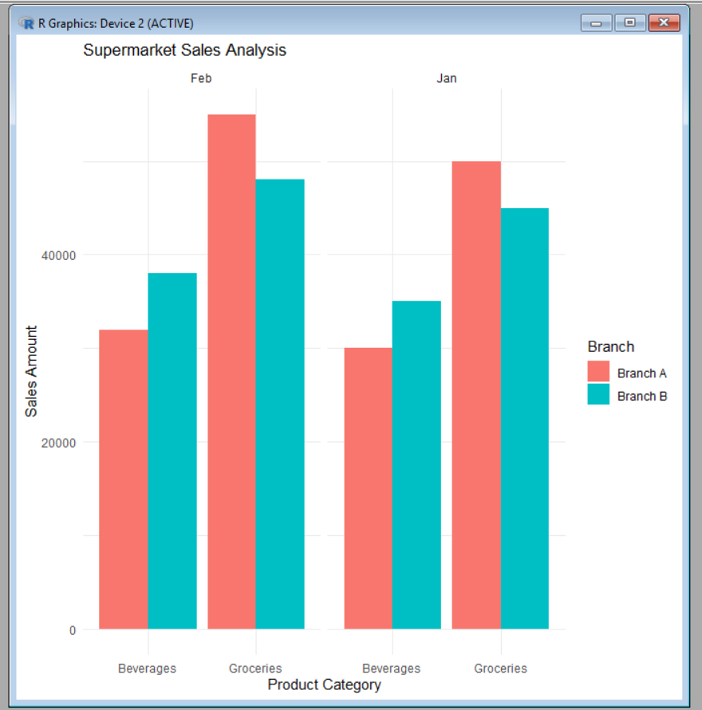
Scenario 6: Employee Salary Distribution

CODE:
# Load ggplot2 package
library(ggplot2)

# Create dataset
employee <- data.frame(
EmployeeID = 1:10,
Salary = c(25000, 30000, 35000, 40000, 45000,
50000, 55000, 60000, 65000, 70000),
Experience = c(1,2,3,4,5,6,7,8,9,10),
Department = c("HR","IT","Finance","Sales","HR",
"IT","Finance","Sales","HR","IT")
)

# Histogram (Bin width = 5000)
ggplot(employee, aes(x = Salary)) +
geom_histogram(binwidth = 5000,
fill = "skyblue",
color = "black") +
labs(
title = "Employee Salary Distribution",
x = "Salary",
y = "Number of Employees"
) +
theme_minimal()

# Histogram (Bin width = 10000)
ggplot(employee, aes(x = Salary)) +
geom_histogram(binwidth = 10000,
fill = "lightgreen",
color = "black") +
labs(
title = "Employee Salary Distribution (Larger Bin Size)",
x = "Salary",
y = "Number of Employees"
) +
theme_minimal()

OUTPUT:
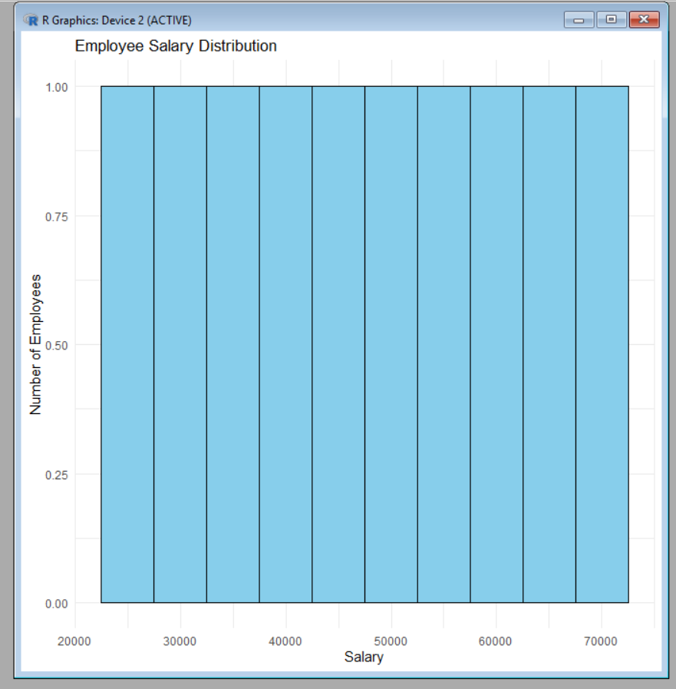
Scenario 7: Smartphone Market Comparison
CODE:
# Load ggplot2 package
library(ggplot2)

# Create dataset
phone <- data.frame(
Brand = c("Samsung", "Apple", "OnePlus", "Xiaomi", "Realme"),
RAM = c(8, 6, 12, 8, 4),
ProcessorSpeed = c(2.8, 3.2, 3.0, 2.6, 2.4), # GHz
Price = c(50000, 80000, 60000, 35000, 20000),
Storage = c(128, 256, 256, 128, 64)
)

# Scatter Plot
ggplot(phone,
aes(x = RAM,
y = Price,
shape = Brand,
size = Storage,
color = ProcessorSpeed)) +
geom_point(alpha = 0.8) +
labs(
title = "Smartphone Market Comparison",
x = "RAM (GB)",
y = "Price",
shape = "Brand",
size = "Storage (GB)",
color = "Processor Speed (GHz)"
) +
theme_minimal()

OUTPUT:
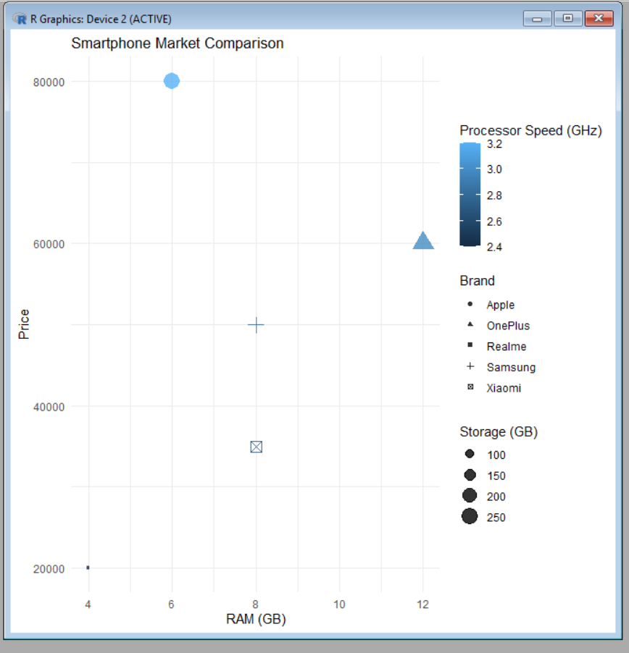

Scenario 8: Online Movie Rating Analysis
CODE:
# Load ggplot2 package
library(ggplot2)

# Create dataset
movie <- data.frame(
Genre = c("Action", "Comedy", "Drama", "Horror", "Romance"),
AverageRating = c(4.5, 3.8, 4.7, 3.5, 4.2),
NumberOfReviews = c(1200, 900, 1500, 700, 1000),
ReleaseYear = c(2022, 2022, 2023, 2023, 2024)
)

# Heatmap
ggplot(movie,
aes(x = factor(ReleaseYear),
y = Genre,
fill = AverageRating)) +
geom_tile(color = "white") +
scale_fill_gradient(low = "yellow", high = "red") +
labs(
title = "Online Movie Rating Analysis",
x = "Release Year",
y = "Genre",
fill = "Average Rating"
) +
theme_minimal()
OUTPUT:
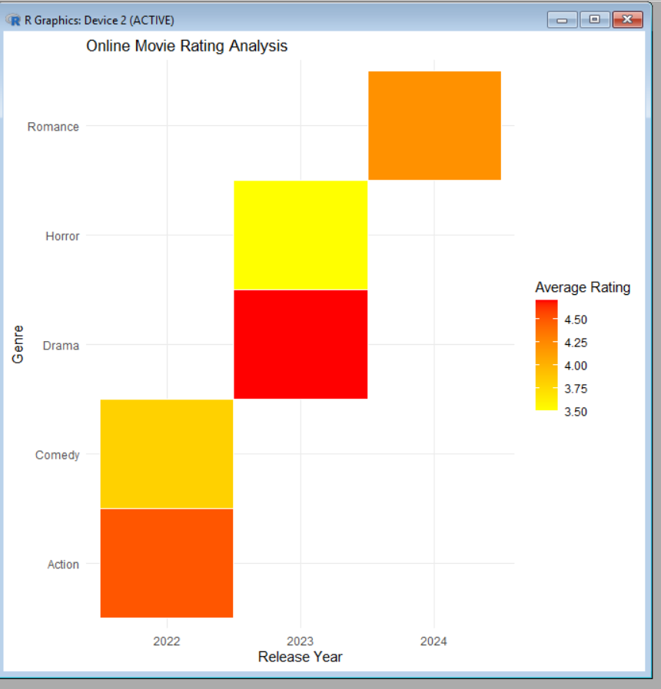
Scenario 9: COVID-19 State-wise Analysis
CODE:
# Load ggplot2 package
library(ggplot2)

# Create dataset
covid <- data.frame(
State = c("Tamil Nadu", "Kerala", "Karnataka", "Maharashtra", "Delhi"),
ActiveCases = c(1200, 1800, 900, 2500, 700),
VaccinationPercentage = c(92, 90, 91, 89, 94),
Population = c(78000000, 35000000, 68000000, 124000000, 20000000)
)

# Tile Plot (Heatmap)
ggplot(covid,
aes(x = "India",
y = State,
fill = ActiveCases)) +
geom_tile(color = "white") +
scale_fill_gradient(low = "lightyellow", high = "red") +
labs(
title = "COVID-19 State-wise Analysis",
x = "",
y = "State",
fill = "Active Cases"
) +
theme_minimal()

OUTPUT:
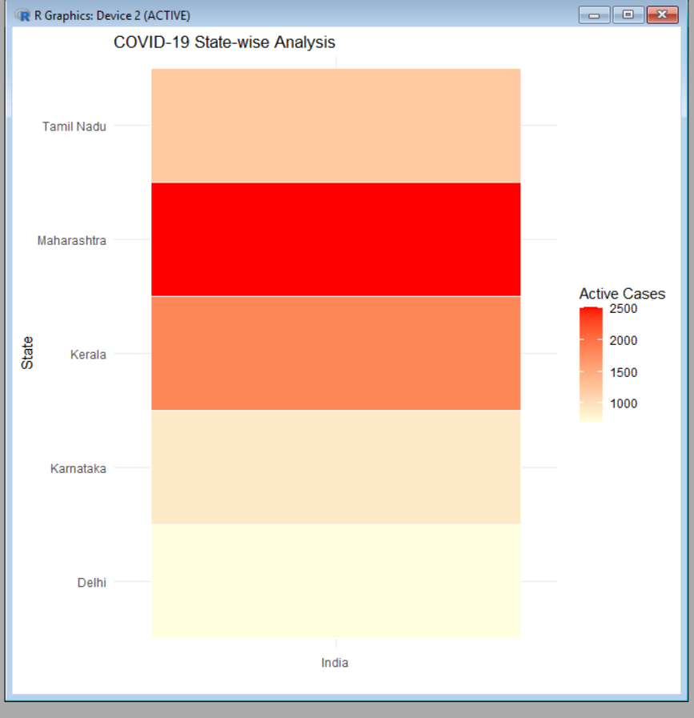

Scenario 10: Iris Flower Classification
CODE:
# Load ggplot2 package
library(ggplot2)

# Use built-in Iris dataset
data(iris)

# Scatter Plot
ggplot(iris,
aes(x = Sepal.Length,
y = Petal.Length,
color = Species,
shape = Species,
size = Sepal.Width)) +
geom_point(alpha = 0.8) +
labs(
title = "Iris Flower Classification",
x = "Sepal Length",
y = "Petal Length",
color = "Species",
shape = "Species",
size = "Sepal Width"
) +
theme_minimal()
OUTPUT:
